RE: *Nathaniel Green v Amy Renee Prince et al., Case No: 35-2022-CA-000361-AXXX-XX, Circuit Court of the 5th Judicial Circuit in and for Lake County, Florida*

Date of Crash: July 12, 2018

Date of Birth: *Nathaniel Green:* March 23, 1983 [35 years old at time of crash]

**Background Facts:**

On July 12, 2018 at about 9:10 am Nathaniel Green was the restrained driver of a 2002 Chevrolet Impala 4DR sedan that was stopped in the westbound inside lane of US Hwy 441/SR 500, near CR 473, Tavares, Florida, behind a 2002 Ford Windstar van, driven by Kevin Evans, that was stopped for traffic ahead of him. Mr. Green began to proceed forward along with traffic ahead of him in response to their traffic light changing from red to green. Traffic ahead of him, including Mr. Evans’ Ford, came to a stop again and Mr. Green came to a stop as well. A 2017 GMC Arcadia SUV, driven by Amy Prince and with Lexie Prince as the second-row right seat passenger, failed to stop in time and struck the rear of Mr. Green’s Chevrolet and the impact pushed it into the rear of Mr. Evan’s Ford. The images below depict an FRA produced diagram (based on the traffic crash report and Mr. Green’s statement) and the subject Chevrolet and Ford, post-collision:

**FRA produced diagram, Mr. Green’s Chevrolet labeled “V2”**

**Mr. Green’s Chevrolet, post-collision**

**Ford, post-collision**

No damage estimate was provided for the Chevrolet for review. The single color photo provided showed damage to the rear bumper cover, rear bumper facia molding, rear bumper facia energy absorber, center rear lighting assembly, left rear lighting assembly, left rear lighting assembly, left rear quarter panel and the trunk lid. The vehicle was deemed a total loss by State Farm Insurance and its cash valuation was $2,418.00. The Chevrolet was not towed from the scene and there was no report of air bag deployment.

No damage estimate was provided for the Ford for review. The single color photo provided showed damage to the rear hatch door. The Ford was not towed from the scene.

No damage estimate or photos for the GMC were provided for review. The police report described the damage as minor with an estimate of $3,000. The GMC was not towed from the scene and there was no report of air bag deployment.

*Post-crash history*

Mr. Green was looking straight ahead at the time of impact; he did not anticipate the collision and did not brace. The impact forced his head and body forward then back into his seat resulting in immediate pain to his neck, upper, middle, and lower back. Mr. Green believed he may have lost consciousness for three to five seconds (or at least an altered level of consciousness where everything went black, but he could still hear everything around him) and immediately had a sensation of pain/pressure across his forehead, neck pain, left shoulder pain and low back pain.

EMS did not respond to the incident and Mr. Green did not proceed to the ED straight away but continued to his place of work.

On July 16, 2018, 4 days after the crash, Mr. Green presented to Dr. Jason Buehler (chiropractic) with complaints of pain in his neck, middle back, lower back, left shoulder and headaches. Mr. Green also developed some ringing in his right ear. He underwent full-spine X-rays which were negative for acute osseous abnormality. Dr. Buehler ordered a CT scan of the cervical spine, initiated treatment modalities and Mr. Green pursued treatment through October 3, 2019.

On October 18, 2018, Mr. Green presented to the Florida Hospital Waterman and underwent an MRI of the left shoulder which revealed non-specific changes at the acromioclavicular (AC) joint with a small effusion, marrow edema and surrounding soft tissue edema (differential diagnosis includes osteoarthritis with reactive effusion and edema, AC joint sprain, inflammatory/infectious arthritis).

On November 8, 2018, Mr. Green underwent an MRI of the cervical spine which revealed: at C3-4, shallow central disk protrusion, moderate right and mild to moderate left neural foraminal stenosis due to facet arthropathy and uncovertebral hypertrophy; at C4-5, minimal disk osteophyte ridge, mild to moderate bilateral neural foraminal stenosis, moderate to severe right and mild to moderate left neural foraminal stenosis; at C5-6, broad shallow disk osteophyte ridge partially effacing the ventral thecal space and producing a minimal spinal canal stenosis, moderate to severe right and mild to moderate left neural foraminal stenosis; at C6-7, posterior annular fissuring and a broad shallow central disk protrusion, mild bilateral neural foraminal stenosis.

On November 24, 2018, Mr. Green presented to the Summerfield ED with complaints of left lower rib pain after a slip and fall incident (he fell onto his left side) after slipping on a greasy surface). X-rays of the left ribs were negative for acute osseous abnormality, and he was diagnosed with rib contusion.

On November 29, 2018, Mr. Green presented to Dr. Richard Smith (orthopedic surgery) with complaints of severe pain in his left shoulder with limited range of motion, and [improving] neck pain, tingling in his hands (more so at night), and sleep disturbance. He was diagnosed with cervicalgia, left shoulder pain, left shoulder adhesive capsulitis, right wrist pain, cervical disk displacement. Dr. Smith ordered electrodiagnostic studies to evaluate for carpal tunnel, provided Mr. Green with bilateral wrist braces; and recommended left shoulder arthroscopy with SLAP lesion repair.

On January 4, 2019, Mr. Green returned to Dr. Smith with additional complaints of pain in his lower back. Dr. Smith prescribed Methocarbamol 750 mg and recommended continuing conservative treatment.

On January 31, 2019, Mr. Green underwent electromyography/ nerve conduction velocity (EMG/NCV) studies, performed by Dr. James Shea (PM&R) which revealed left carpal tunnel syndrome.

On February 19 (and through April 16, 2019), Mr. Green returned to Dr. Smith for further evaluations. He diagnosed carpal tunnel syndrome and reiterated recommendations for undergoing a left shoulder arthroscopy with left carpal tunnel release, ordered an MRI of the lumbar spine, recommended cervical epidurals, and prescribed Tramadol 50 mg.

On May 2, 2019, Mr. Green underwent a lumbar spine MRI which revealed: at L3-4, mild facet arthrosis and ligamentum flavum thickening; at L4-5, slight disk bulge with mild to moderate facet arthropathy and mild thickening of ligamentum flavum, minimal bilateral neuroforaminal narrowing; at L5-S1, posterior annular fissure with a disk bulge with a small central disk protrusion, and minimal facet arthrosis.

**On May 10, 2019, Mr. Green underwent left carpal tunnel release; left shoulder arthroscopy with extensive debridement, repair of type II superior labrum anterior and posterior (SLAP) lesion, acromial decompression, atrial distal clavicle resection and interlaminar cervical epidural steroid injection at C6-7, performed by Dr. Smith.**

On June 6, 2019, through October 18, 2019, Mr. Green underwent rehabilitative physical therapy at CORA.

On June 10, and 24, 2019, Dr. Smith performed cervical interlaminar epidural steroid injections (ESI) at C6-7 due to persistent cervicalgia.

Dr. Smith discussed proceeding with a series of lumbar spine epidurals due to increasing pain in his lower back, also.

On July 22, August 19 and September 16, 2019, Mr. Green underwent a series of lumbar ESIs, at L5-S1.

On October 14, 2019, Mr. Green updated the cervical and lumbar MRIs. The lumbar spine study revealed: at L5-S1, a central posterior disk herniation indenting the ventral thecal sac and elevating the posterior longitudinal ligament with a zone hyperintensity within the disk herniation consistent with annular fissure and decrease in disk space signal.

The cervical spine study revealed: at C4-5, disk bulging; resulting in anterior impression on the thecal sac; at C5-6, a central posterior disk herniation indenting the ventral thecal sac and elevating the posterior longitudinal ligament with a zone of hyperintensity within the disk herniation consistent with an annular fissure, decrease in disk space height; at C6-7, a central posterior disk herniation indenting the ventral thecal sac and elevating the posterior longitudinal ligament with an area of hyperintense signal within the disk suggestive of a more acute herniation.

On November 22, 2019, and February 25, 2020, Mr. Green returned to Dr. Smith’s office. He had persistent pain in his neck and lower back. Mr. Green declined further cervical ESIs; a Joi Max procedure was recommended for the cervical spine and a lumbar [micro-endoscopic] discectomy on the right at L5-S1 to treat the lower back symptomatology. He was also provided with prescriptions for hydrocodone 7.5 mg, Ibuprofen 800 mg, and Tizanidine 4 mg.

On March 9, 2020, Mr. Green updated the lumbar MRI which revealed: at L5-S1, a broad based posterior central disk herniation demonstrating an annular fissure, elevation of the posterior longitudinal ligament, small osteophytes (disk herniation extending beyond the osteophyte margin), mild central canal stenosis (1.0 cm); stable findings since the prior study.

On July 30, 2020, Mr. Green presented to Dr. Andrew Messer (orthopedic spine surgery). In addition to persistent cervical and lumbar symptomatology, he reported tinnitus, and headaches. Dr. Messer discussed proceeding with cervical/lumbar medial branch blocks possibly progressing to radiofrequency nerve ablations.

On August 17, Dr. Smith released Mr. Green to pain management and neurosurgery for further evaluation and treatment.

On August 27, 2020, Mr. Green underwent lumbar medial branch blocks on the left at L4-5 with 100% relief. Bilateral neurotomies at L4-5 (left) were subsequently recommended, which Dr. Messer performed on September 18, 2020. Mr. Green experienced 15-20% symptom relief.

On October 26, 2020, Dr. Messer performed cervical medial branch block injections on the left at C6-7. Dr. Messer recommended pursuing a Cervical Elliquence procedure at C5-6 and 6-7 with persistent pain.

On November 6, 2020, Brittany Wright PA-C to Dr. Messer discussed possible laminectomy with laser assisted annuloplasty at L5-S1.

**On November 12, 2020, Dr. Messer performed an L5-S1laminotomy, medial facetectomy, neural foraminotomy, decompression of the S1 nerve with laser assisted annuloplasty at L5-S1; and C5-7 discogram followed by anterior discectomy, nuclear modulation and annuloplasty using Elliquence technique.**

On December 23, 2020, Mr. Green presented to the ED with acute severe lumbar pain for the prior two days with associated headache and nausea. On examination he had a small open area with a possible Vicryl local suture reaction. He was diagnosed with a post-surgery wound infection and released home.

On January 31, 2021, Mr. Green revisited Brittany Wright PA-C with complaints of constant pain in his neck radiating to the left upper extremity with numbness and tingling in his hands, and lower back pain radiating into the right buttock, right hip, and right thigh.

On February 5, 2021, Mr. Green underwent a further lumbar MRI which revealed: multilevel mild spondylosis; right laminectomy/fenestration surgery at L5-S1 with post-operative edema and corresponding enhancement extending from the right side of the spinal anal to the right posterior paraspinal region; posterior herniation at L4-5 and L5-S1 with mild central spinal stenosis and bilateral neural foraminal stenosis, abutment of the right traversing nerve root at L5-S1.

By February 15, 2021, Mr. Green had developed severe pain in his left hip.

On March 16, 2021, Dr. Sidney Swartz (anesthesiology) performed a left sacroiliac joint injection, with 30 % improvement.

On April 13, 2021, Dr. Swartz performed a lumbar epidural steroid injection (ESI), providing 20-30 % relief.

Dr. Messer discussed proceeding with left lumbar medial branch bocks (MBB)/nerve ablations.

On June 10, 2021, Dr. Swartz performed left L3-5 MBBs and recommended a right piriformis injection.

On July 15, 2021, Mr. Green presented to Dr. Dylan Saulsberry (chiropractic neurology) with complaints of persistent headaches, dizziness/vertigo, since the crash, occurring 3-4 times/week, brain fog, poor concentration, and a short attention span. Extensive neurological evaluation revealed post concussional syndrome/mild traumatic brain injury for which Dr. Saulsberry recommended obtaining a brain MRI, and concussion related home exercises.

On July 21, 2021, Mr. Green underwent an MRI of the brain which revealed: multifocal abnormal signal changes within both the right and left frontal lobes, specifically involving the gray/white matter (typical area associated with a traumatic brain injury). NeuroQuant analysis demonstrated abnormally small sizes of the brain involving the left basal ganglia, the left occipital lobe, and the bilateral temporal lobes (possibly representing posttraumatic atrophy; whole brain analysis demonstrated visible reductions in fractional anisotropy corresponding with areas of abnormal signal of the standard MRI. Tractography imaging demonstrated reductions in fractional anisotropy involving both the right and left frontal lobes, scattered defects in the bilateral parietooccipital regions (consistent with axonal injury). Overall findings consistent with the diagnosis of traumatic brain injury.

On August 19, 2021, Dr. Swartz performed a *left* piriformis steroid injection.

On September 9, 2021, Mr. Green underwent EMG/NCV studies of the right lower extremity which revealed evidence of lumbosacral radiculopathy.

On September 23, 2021, Mr. Green underwent bilateral upper extremity EMG/NCV studies due to persistent paresthesias which revealed: left mild cubital tunnel syndrome.

On February 12, 2024, Mr. Green presented to Danielle Johnson APRN (neurosurgery) with complaints of persistent headache, left sided neck pain radiating to the left upper extremity, left sided lower back pain radiating into the left gluteal region and right thigh. Ms. Johnson diagnosed a left C5 radiculopathy and recommended obtaining an MRI of the lumbar spine. Height: 5 ft 8 inches, weight: 205 lbs.

*Pre-crash medical history*

Mr. Green was in a prior traffic crash (passenger) in 2004, injuring his neck. His neck pain resolved with pain management and physical therapy.

*Documents reviewed*

Physical Medicine Pain Center, EMG/NCV studies, Dr. Shea

CORA Physical Therapy

SimonMed MRIs

Florida Center for Ortho, Dr. Smith

Florida Hospital Waterman ED/MRI

Akumin, MRI

Buehler Family Chiropractic

CFI (Centers for Imaging)

Nathan Green, deposition July 10, 2023

Global Microsurgical Center, operative report 5-10-2019

Interventional Associates of Leesburg

Orlando Center for Outpatient Surgery, operative report

Spine and Brain Neurosurgery Center

*Reconstruction:*

According to the police report it was daylight, clear and the roadway was dry. The speed limit on US Hwy 441/SR 500 was 45 mph.

Mr. Green, deposed on July 10, 2023, testified that they were all stopped for a red light, he was behind the Ford van, and he was able to see its rear tires. The light turned green, the vehicles ahead of him began to go and then a couple of vehicles ahead of him, including the Ford van, came to a stop. He brought his vehicle to a stop, but the lady behind him (in the GMC) did not stop. She struck his vehicle in the rear and the impact into his vehicle was hard enough to push him about 3 to four feet, if not more, into the Ford van ahead of him. The impact was painful, there were about 3 to 5 seconds where he didn’t see anything and everything was black. He did not think he lost consciousness as he could hear what was going on around him.

No deposition of Ms. Prince was provided for review. She told police that all traffic had begun to move forward, she turned around to check on her daughter in the backseat, and all traffic ahead of her came to a sudden stop.

No deposition of Mr. Evans was provided for review. He told police that a vehicle in front of him came to a stop and he brought his vehicle to a stop as well.

Opinions of defendant reconstruction expert

Dr. Xiao, deposed on February 29, 2024, testified that he was retained to reconstruct the crash and to complete a biomechanical analysis involving Mr. Green. He completed a 52-page report in addition to having a project file related to the subject crash. He would be offering opinions on causation related to the general population and nothing specific to Mr. Green. His report contained 6 conclusions/bullet points which were:

* The collision was in-line.
* The Chevrolet experienced a forward direction and delta V of less than 8 mph due to the contact from the GMC and subsequently a rearward directed delta V of less than 5 mph due to the contact with the Ford (based on damage evaluation, crush energy calculations and a comparative damage analysis).
* During the contact with the GMC, Mr. Green would have moved rearward into the seat foam, followed by a forward motion controlled by his spinal muscles and the seat belt. The forward rebound motion was between 3 and 5 mph and was similar to walking slowly and a slow jogging speed.
* The motions and loading to Mr. Green’s body were less than, or comparable to, those in simple physical tasks and non-injurious activities.
* The mechanism of injury for disc herniation was not present.
  + The compressive force to the cervical spine was about 13 to 26 pounds.
* The mechanism of injury associated with a shoulder rotator cuff rear or labral tear was not present.
* The mechanism of injury for acute carpal tunnel syndrome was not present, however, a mechanism for aggravation was.
* The mechanism of injury associated with spinal muscle strains and joint strains can’t be ruled out.
* He utilized peer reviewed mechanical studies using crash testing devices, human volunteers, cadavers, and real world crash data in the formation of his opinions. He also compared the forces of the crash to riding in amusement park bumper car rides.

The police report authored by Corporal Helms stated that Mr. Evans came to a stop in the inside westbound lane of SR 500 due to traffic and a red light ahead. Mr. Green came to a stop behind him. The light turned green, all traffic began to move forward and the vehicle in front of Mr. Evans came to a stop again. Mr. Evans came to a stop as did Mr. Green. Ms. Prince failed to stop and struck the rear of Mr. Green’s stopped Chevrolet, pushing it forward into the rear of Mr. Evans’ stopped Ford. The area of impact was about 386’ east of the intersection. The estimated speed for Ms. Prince’s GMC at impact was 15 mph.

The following documents/files were provided and reviewed for the preparation of this report:

Florida Highway Patrol crash report

State Farm Insurance correspondence letter dated May 3, 2019, to Mr. Green

1 color photograph of Mr. Green’s Chevrolet

1 color photograph of Mr. Evans’ Ford

Deposition of Nathaniel Green dated July 10, 2023

Deposition of Dr. Ming Xiao dated February 29, 2024

Florida Center for Orthopaedics encounter document dated September 15, 2020

*Crash Analysis:*

Deformation to the rear of the Chevrolet extends beyond the bumper plane into the trunk area and likely includes the rear body panels. Deformation is estimated at about 5-6 inches. Deformation to the rear of the Ford also extends beyond the bumper plane is estimated at about 3+ inches.

A widely used crash simulation program[1] is capable of modeling deformation and depth of penetration or maximum engagement during a collision. By overlapping the damage between scale models of the involved vehicles as observed in the photos, I can model the subject crash to determine a closing speed estimate, which will in turn, estimate an approximate speed change or delta V imparted to the Chevrolet in the crash by using a momentum, energy and restitution (MER) analysis, and then matching these results to the physical and other evidence.

An impact speed of 20 mph from the GMC would have resulted in a delta V in the Chevrolet of approximately 13.6 mph, with a peak vehicle acceleration for the impact of approximately 9.9 g. Impact speed of the Chevrolet into the Ford is approximately 13 mph resulting in a delta V of 8.5 mph and a peak acceleration of 6.8 g in the Chevrolet. Deformation (overlap or depth of penetration) between the GMC and the Chevrolet and the Chevrolet and Ford is shown below and is fairly consistent with what is observed in the photos. Delta V to the GMC is approximately 10.7 mph which is consistent with an airbag non-deployment.

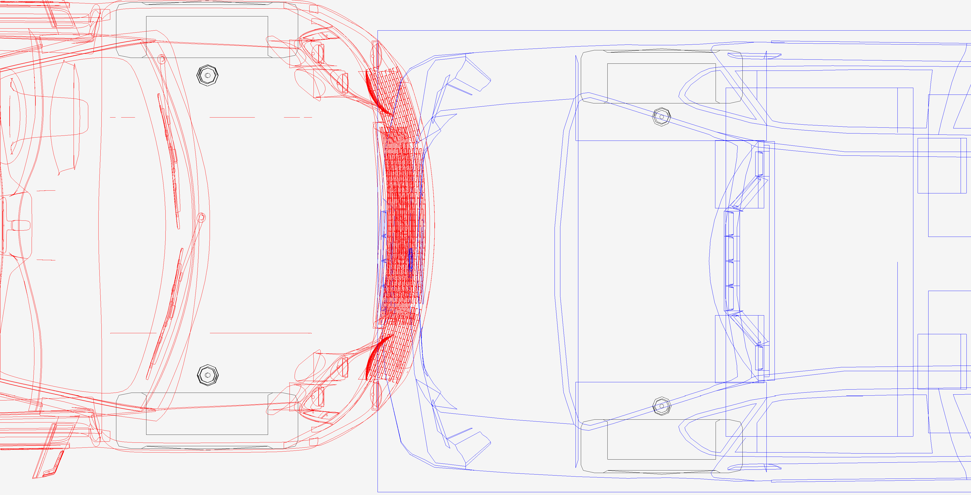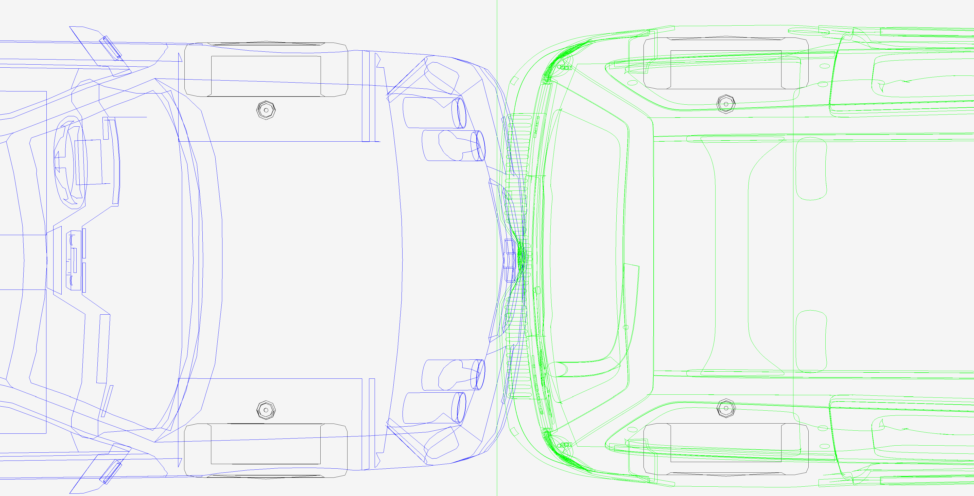

**Simulated 20 mph depth of penetration (overlap or maximum engagement) between the GMC and Mr. Green’s Chevrolet (left photo) and between the Chevrolet and Ford (right photo) is fairly consistent with photos. Chevrolet is the blue vehicle.**

Dr. Xiao claims he used a crush analysis to arrive at a less than 8 mph delta V in the GMC/Chevrolet collision. Using the simulator to evaluate an 8-mph delta V in the Chevrolet would indicate a 12 mph impact speed by the GMC into the Chevrolet. This would result in 7.5 mph impact by the Chevrolet into the Ford and results in a 5-mph delta V in the Chevrolet. Below is the simulator depth of penetration based on Dr. Xiao’s crush results. The simulation results show there is not enough engagement between the vehicle to cause the damage observed in the photos. The results indicate Dr. Xiao underestimated his results by nearly 60%.

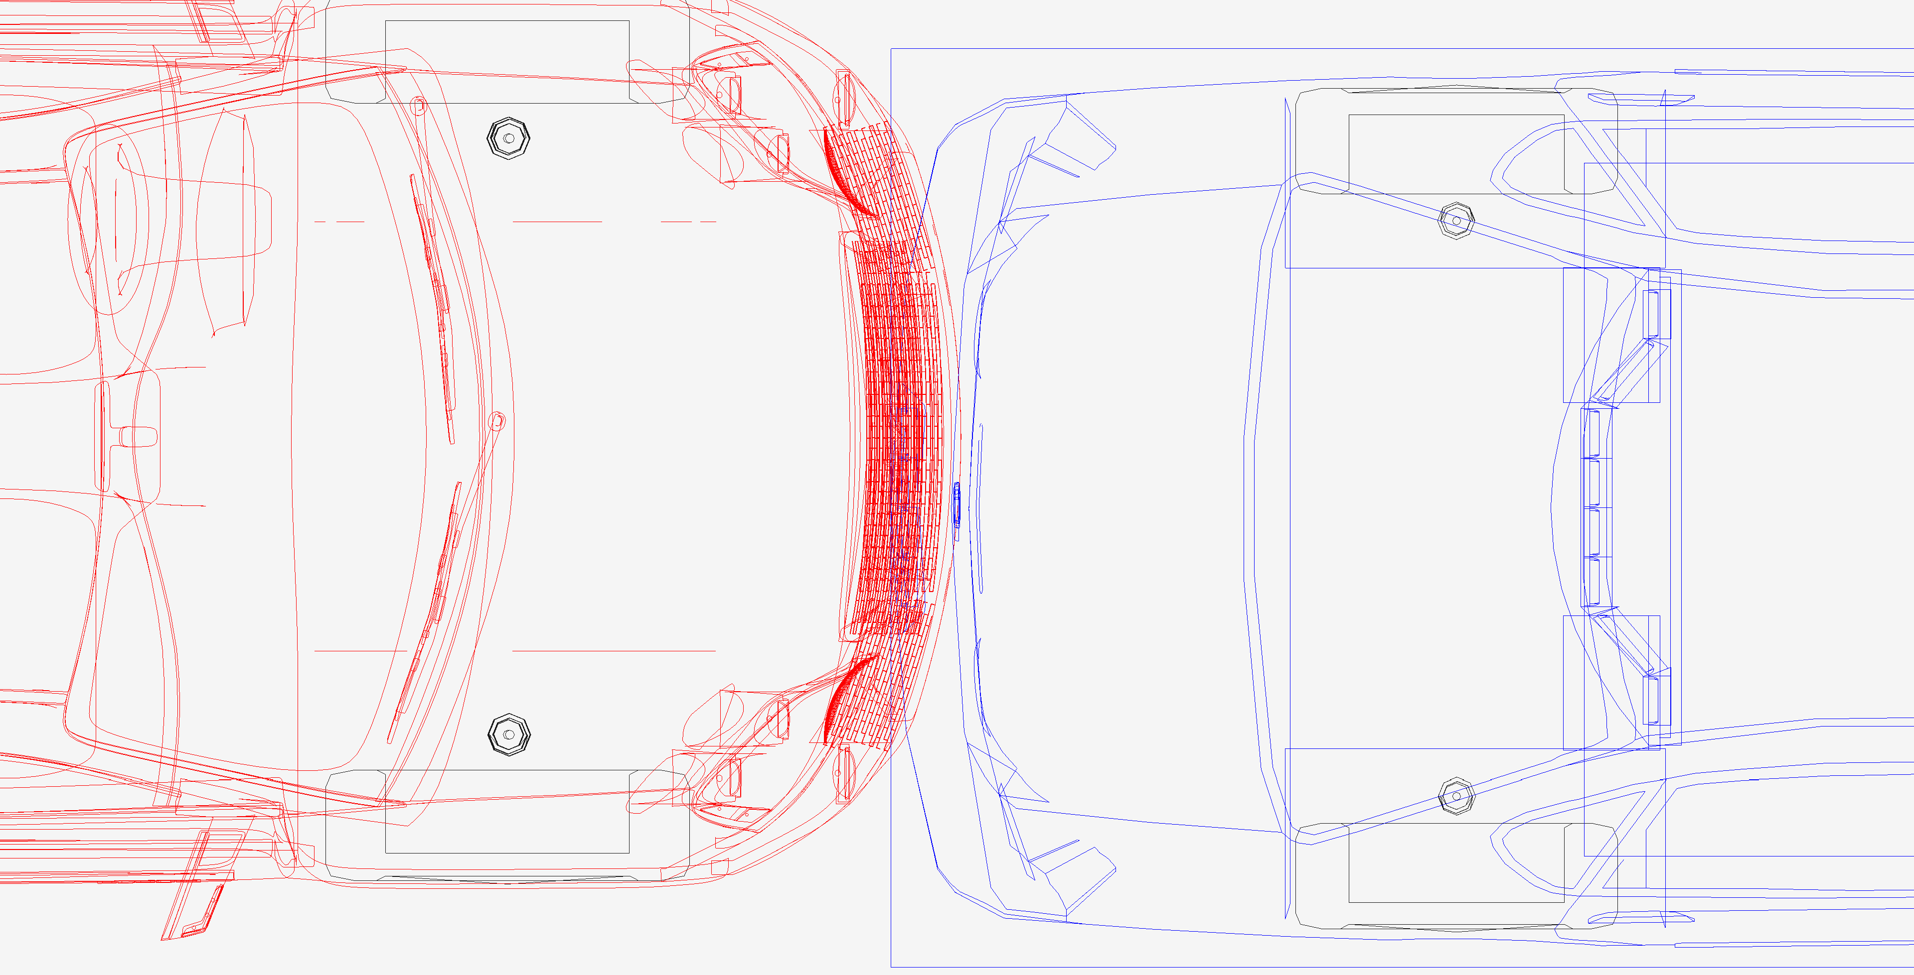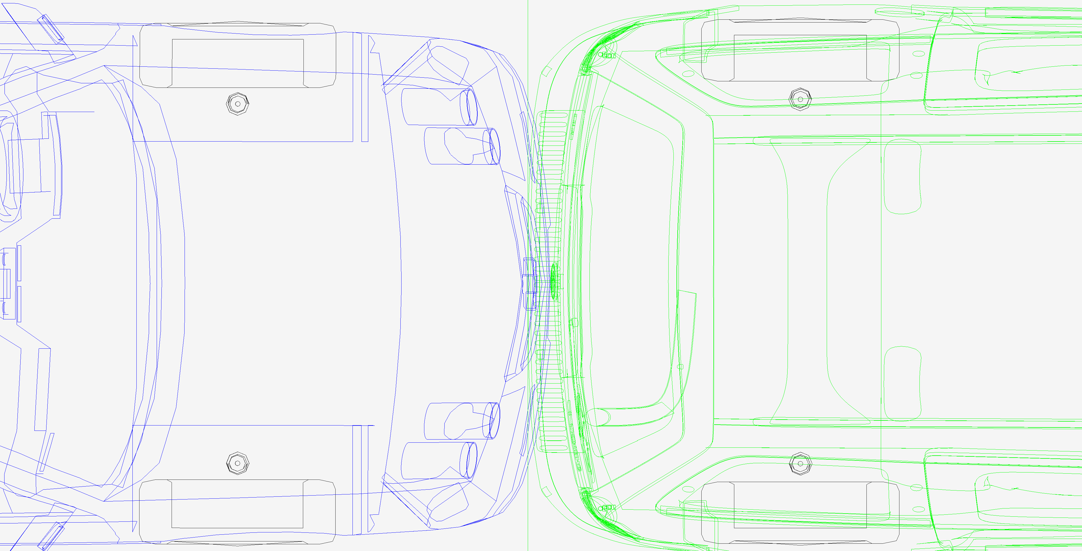

**Maximum engagement (depth of penetration) using Dr. Xiao’s crush calculation results. It is obvious that there is not enough engagement between the vehicles to cause the deformation shown in the photos.**

1. Virtual Crash 5, vCrash America Inc.